Step 1 :
Make a folder
Open in VSCode.

Step 2:
In terminal navigate to the folder
npm init -y (equi to Spring Initializr generating pom.xml. After running, you'll see package.json)

Open it.
You'll see something like

{
"name": "studentmanagemnt",
"version": "1.0.0",
"description": "",
"main": "index.js",
"scripts": {
"test": "echo \"Error: no test specified\" && exit 1"
},
"keywords": [],
"author": "",
"license": "ISC",
"type": "commonjs"
}

Replace values of “scripts” object with
"scripts": {
"start": "node src/server.js",
"dev": "nodemon src/server.js"
},

Step 3 : Install Express
npm install express (equivalent to spring-boot-starter-web dependency)

Step 4 : Install MongoDB Library
npm install mongoose (equivalent to jpa / hibernate dependency)

Step 5 : Install dotenv
npm install dotenv (equivalent to application.properties)

Step 6: Install Nodemon
npm install --save-dev nodemon ( equivalent to dev-tools dependency)

after installing the dependencies the package.json should lool like
{
"name": "studentmanagemnt",
"version": "1.0.0",
"description": "",
"main": "index.js",
"scripts": {
"test": "echo \"Error: no test specified\" && exit 1"
},
"keywords": [],
"author": "",
"license": "ISC",
"type": "commonjs",
"dependencies": {
"dotenv": "^17.4.2",
"express": "^5.2.1",
"mongoose": "^9.7.4"
},
"devDependencies": {
"nodemon": "^3.1.14"
}
}

Step 7 : project folder structure

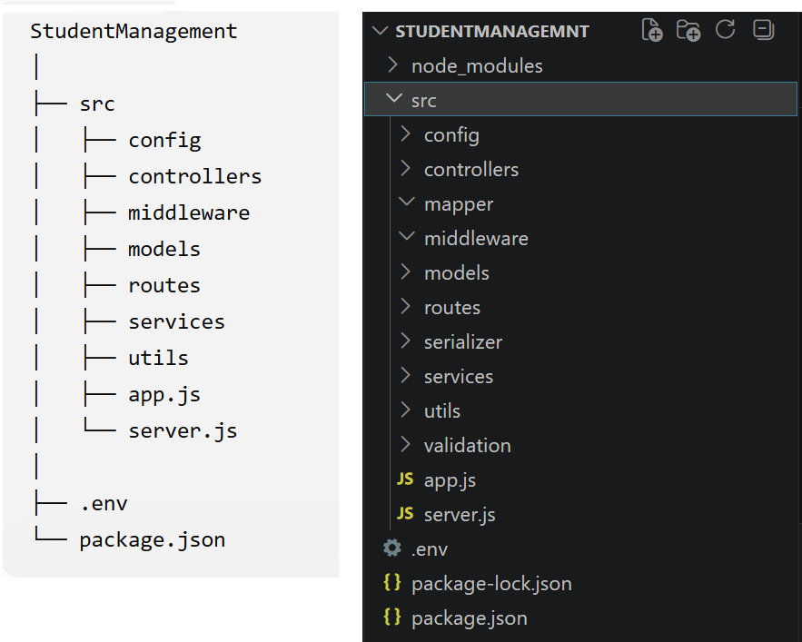

Step 8: create .env file (equivalent to application.properties)

PORT=3000

MONGO_URI=mongodb://localhost:27017/studentdb

Step 9: inside server.js file (equivalent to SpringApplication.run(...) its Starts the HTTP server)

const app = require("./app");

const PORT = process.env.PORT || 3000;

app.listen(PORT, () => {
console.log(`Server running on port ${PORT}`);
});

Step 10: inside app.js file (equivalent to @SpringBootApplication & @RestController used for Defines the Express application (routes, middleware, configuration))

require("dotenv").config();

const express = require("express");

const app = express();

app.use(express.json());

app.get("/", (req, res) => {
res.send("Welcome to Student API");
});

module.exports = app;

Step 11 : Run Project
npm run dev

Step 12 : open browser
http://localhost:3000
output : Welcome to Student API

